**fresh** OFFICIAL MAGAZINE OF THE ASSOCIATION FOR LINEN MANAGEMENT

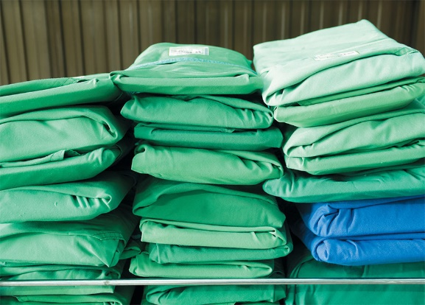PACKROOM SERVICES

BY SUSANNA DANIEL

PHICHET CHAIYABIN/SHUTTERSTOCK.COM

**PACKROOM SERVICES**

**IT’S BEEN EIGHTEEN MONTHS** since 19.1 million disposable surgical gowns were recalled because of unknown conditions at a plant in China, an event that is anticipated to turn the trend back toward reusable textiles throughout the healthcare industry.

Today, amid an ongoing pandemic and continued gown shortages, more healthcare facilities are reconsidering their decision to use disposables products.

“Reusable surgical textiles are becoming more popular again,” said Dave Fox, Senior Operations Manager for Surgical Services (SurgiTex) at Standard Textile. Fox provides Standard Textile customers with the necessary tools, guidance, and resources to develop and operate their own surgical textile pack rooms.

Most packrooms are located in laundries, and they’re used for sterile, surgical textiles like gowns and towels, as well as specialty items, such as incubator covers, drape sheets, and mayo stand covers, and certain types of healthcare uniforms, like some lab coats.

In the packroom, each item is inspected, folded, packed, stored, and transported safely to hospital operating theaters or other sterile environments, without compromising sterility. A packroom also has the capability of tracking a linen’s life cycle using RFID chips, barcodes, or usage charts.

“Organizations who were already using reusables had a significantly easier time managing the recent crisis, not to mention other disruptions to the supply chain,” said Fox. If a facility owns 30,000 surgical gowns, for example, and each gown is good for 75 cycles, that’s the equivalent of 2.3 million disposable isolation gowns.

“Think of the landfill,” said Rocco Romeo, CEO of HLS Linen Services. “Also, a reusable supply guarantees that you will have the product when you need it.”

Disposable products have other downsides, too. Before the recalls in 2019, there was a widespread assumption that every disposable item was perfect — now we know that’s not the case.

“There’s no longer the assumption that disposables are above quality control,” said Romeo. “One of the key threats to the linen business is disposable products, so we have to have a first-rate product that’s comparable to what a disposable can provide.”

Unfortunately, healthcare organizations with access to packrooms are in the minority. Fox estimates that only 15-20% of healthcare facilities and hospitals in the United States maintain their own packrooms on-site. Most facilities are still heavily dependent on disposable textiles, which means they are heavily dependent on foreign suppliers and manufacturers — a supply chain that has proven vulnerable in a situation with no room for error.

“Now we know beyond a shadow of a doubt that those supply chains aren’t strong enough,” said Fox.

Currently, there are three options in terms of how to pack specialty, sterile garments for an operating room or other sterile environment. A hospital can maintain an on-site packroom, which means a dedicated physical space and highly trained staff; or contract with a laundry that has a packroom on site; or hire the services of a third-party packroom.

Despite the value of a packroom, it’s not easy to justify the expense of running one on-site.

“Operating room pack rooms are a specialty area,” he said. “We’re always working to improve our processes and standards, educate our employees, improve our wash process and formulas for these barrier fabrics and enhance infection control policies and processes.”

**PACKROOM OPERATIONS**

Packrooms must be operated in accordance with ANSI/AAMI ST65:2008/(R) 2013, which designates the design of the work area and facility, guides laundering, inspection, testing, and maintenance processes, and addresses preparations and packaging of packs.

To ensure a first-rate product, a packroom is uniquely set up to inspect items for stains, tears, wear, lint, holes, and other defects that might affect the durability of a textile in a sterile environment. Gown ties and snaps are inspected, too.

“Everything has to be free of any defect that might allow a strike through,” said Romeo. “Our emphasis must be on quality control at all times, or else a defect could affect a surgery being performed.”

“We’re always working toward better staff training and education,” said Romeo. “All OR linen items are inspected at a light table to ensure the efficacy of the barrier fabrics and for any other issues such as staining or ALMnet.org SUMMER 2020 fresh 11 holes. It’s a critical part of our process in ensuring high-quality OR products are provided. Everything has to be free of any defect that might allow a strike through. Our emphasis must be on quality control at all times, or else a defect could affect a surgery being performed.”

**In the packroom, each item is inspected, folded,**

**packed, stored and transported safely to hospital operating theaters or**

**other sterile environments, without compromising sterility.**

In addition to the focused inspection services a packroom provides, they’re also equipped to provide specific folding services. ANSI/AAMI ST65:2008/(R) 2013 states the items used in the surgical environment be folded, assembled and wrapped in a manner that permits sterilization and enables efficient use with little chance of contamination.

Staff in a packroom must wear attire that prevents introduction of foreign debris in the packs. Such attire may include dedicated uniforms or cover ups, hairnets and beard coverings. Additionally, the room is climate controlled, with special egress, and there are no guests or visitors unless they’re authorized and also wearing appropriate attire.

“Individual folded components are put into the pack in a specific order and position for assembly and unpacking,” said Fox.

In most cases, the laundry provides a nonsterile pack and the customer performs the sterilization on site. In other cases, the packs are sterilized, then a wrapper or lock on the cart maintains the sterility during transit. If sterilization processes are performed by a laundry or any facility outside of a hospital, they must comply with FDA requirements, which is an intensive and expensive process.

When a customer is looking to contract with a packroom, Fox recommends doing an on-site inspection, which is the best way to confirm that the packroom is adhering to all necessary guidelines.

“If a packroom isn’t independently certified, that’s OK, but then I’d need to have a thorough site visit and confirm that they’re following standards,” said Fox. ●